How Scoring Responses Change Attribution Evaluation in a Diffusion Policy
Arjun Bajpai^{1*}
¹Independent Researcher; Windermere, Florida, United States.
*Corresponding author. Email: arjunbajpai2009@gmail.com
Abstract
Feature attribution evaluation depends on the response used to score predictions after inputs are removed or restored. We separate the attribution target from the scoring response for a robot diffusion policy, comparing squared action discrepancy (Q) with stabilized distance (N). An exact identity shows that N cannot increase insertion or deletion area under the curve (AUC) when interventions remain within the endpoint range. Overshoots, which move the prediction farther from the reference action than replacing every feature with its baseline, can reverse this effect. Saved PickCube cohorts contain no successful episodes; their eight paired median Q-minus-N differences range from 0.104 to 0.159, while extreme calls reverse six means. Historical RDT-1B rescoring gives positive vision medians in successful and failed groups. A new experiment preserves inputs for 281 contexts and compares seven rankings with matched random and fixed orders. The preferred vision-deletion method changes between responses in all three new banks; only one cell has an adjusted best-minus-second interval excluding zero. Numerical comparisons separate completeness, coordinate error, ranking stability and AUC sensitivity. Increasing integration budgets reduces fp32 residuals but leaves a bf16-forward floor; no nonfinite value occurs at 815,210 evaluated nodes. These limited context samples do not estimate general failure rates or verify the original saved rankings. Response calibration can change practical comparisons, and numerical checks require separate interpretation from ranking quality.
Keywords: integrated gradients, attribution evaluation, diffusion policies, perturbation metrics, numerical integration, robotics
Introduction
Diffusion policies generate action sequences by denoising predictions conditioned on observations ((C. Chi, S. Feng, Y. Du, Z. Xu, E. Cousineau, B. C. M. Burchfiel, S. Song. Diffusion policy: Visuomotor policy learning via action diffusion. In Proceedings of Robotics: Science and Systems (RSS) 2023. https://doi.org/10.15607/RSS.2023.XIX.026.)). Their vector outputs require a scalar function for feature attribution or perturbation evaluation ((H. Zhang, M. Xu, A. Dhafer, S. Yue, H. Dong, Z. D. Hao. Embodied interpretability: Linking causal understanding to generalization in vision-language-action models. In Proceedings of the 43rd International Conference on Machine Learning (ICML) Vol. 306 pg. 159526–159549, 2026. https://proceedings.mlr.press/v306/zhang26gz.html.)). Integrated Gradients (IG) integrates sensitivity along a baseline-to-input path ((M. Sundararajan, A. Taly, Q. Yan. Axiomatic attribution for deep networks. In Proceedings of the 34th International Conference on Machine Learning (ICML) Vol. 70 pg. 3319–3328, 2017. https://proceedings.mlr.press/v70/sundararajan17a.html.)); we study this procedure with the Robotics Diffusion Transformer (RDT) ((S. Liu, L. Wu, B. Li, H. Tan, H. Chen, Z. Wang, K. Xu, H. Su, J. Zhu. RDT-1B: A diffusion foundation model for bimanual manipulation. In Proceedings of the International Conference on Learning Representations (ICLR) pg. 29982–30009, 2025. https://proceedings.iclr.cc/paper_files/paper/2025/hash/49f80e4d2471ad4f2edf4f5f1ab62339-Abstract-Conference.html.)). The function being attributed and the response scoring subsequent interventions are distinct choices.
Insertion and deletion tests progressively restore or remove ranked features ((V. Petsiuk, A. Das, K. Saenko. RISE: Randomized input sampling for explanation of black-box models. In Proceedings of the British Machine Vision Conference (BMVC) 2018. https://bmva-archive.org.uk/bmvc/2018/contents/papers/1064.pdf.)). Retraining after removal ((S. Hooker, D. Erhan, P.-J. Kindermans, B. Kim. A benchmark for interpretability methods in deep neural networks. In Advances in Neural Information Processing Systems (NeurIPS) Vol. 32 pg. 9734–9745, 2019. https://proceedings.neurips.cc/paper_files/paper/2019/hash/fe4b8556000d0f0cae99daa5c5c5a410-Abstract.html.)), information exposed by masks ((Y. Rong, T. Leemann, V. Borisov, G. Kasneci, E. Kasneci. A consistent and efficient evaluation strategy for attribution methods. In Proceedings of the 39th International Conference on Machine Learning (ICML) Vol. 162 pg. 18770–18795, 2022. https://proceedings.mlr.press/v162/rong22a.html.)) and disagreeing perturbation metrics ((R. Tomsett, D. Harborne, S. Chakraborty, P. Gurram, A. Preece. Sanity checks for saliency metrics. In Proceedings of the AAAI Conference on Artificial Intelligence Vol. 34 pg. 6021–6029, 2020. https://doi.org/10.1609/aaai.v34i04.6064.)) complicate interpretation. Removal frameworks distinguish the intervention, model behavior and summary ((I. Covert, S. Lundberg, S.-I. Lee. Explaining by removing: A unified framework for model explanation. Journal of Machine Learning Research. Vol. 22, pg. 1–90, 2021, https://jmlr.org/papers/v22/20-1316.html.)). Artificial inputs can leave the training distribution ((P. Hase, H. Xie, M. Bansal. The out-of-distribution problem in explainability and search methods for feature importance explanations. In Advances in Neural Information Processing Systems (NeurIPS) Vol. 34 pg. 3650–3666, 2021. https://proceedings.neurips.cc/paper_files/paper/2021/hash/1def1713ebf17722cbe300cfc1c88558-Abstract.html.)); insertion/deletion AUC also discards attribution magnitudes once their ranking is fixed ((T. Gomez, T. Fréour, H. Mouchère. Metrics for saliency map evaluation of deep learning explanation methods. In Pattern Recognition and Artificial Intelligence. ICPRAI 2022. Lecture Notes in Computer Science Vol. 13363 pg. 84–95, 2022. https://doi.org/10.1007/978-3-031-09037-0_8.)). Meta-evaluation tests metric reliability ((A. Hedström, P. L. Bommer, K. K. Wickstrøm, W. Samek, S. Lapuschkin, M. M.-C. Höhne. The meta-evaluation problem in explainable AI: Identifying reliable estimators with MetaQuantus. Transactions on Machine Learning Research. 2023, https://openreview.net/forum?id=j3FK00HyfU.)), while occlusion strategy can change method rankings ((S. Blücher, J. Vielhaben, N. Strodthoff. Decoupling pixel flipping and occlusion strategy for consistent XAI benchmarks. Transactions on Machine Learning Research. 2024, https://openreview.net/forum?id=bIiLXdtUVM.)). Baseline choice similarly changes the question answered in regression ((A. Mamalakis, E. A. Barnes, I. Ebert-Uphoff. Carefully choose the baseline: Lessons learned from applying XAI attribution methods for regression tasks in geoscience. Artificial Intelligence for the Earth Systems. Vol. 2, 2023, https://doi.org/10.1175/AIES-D-22-0058.1.)).
Policy explanations have additional interpretation problems. Counterfactual tests challenge saliency-based hypotheses in reinforcement learning ((A. Atrey, K. Clary, D. Jensen. Exploratory not explanatory: Counterfactual analysis of saliency maps for deep reinforcement learning. In Proceedings of the International Conference on Learning Representations (ICLR) 2020. https://openreview.net/forum?id=rkl3m1BFDB.)); evaluating action preference differs from evaluating state value ((T. Huber, B. Limmer, E. André. Benchmarking perturbation-based saliency maps for explaining Atari agents. Frontiers in Artificial Intelligence. Vol. 5, pg. 903875, 2022, https://doi.org/10.3389/frai.2022.903875.)). Input attribution has been adapted to robotic torque outputs ((S. Kim, J. Choi. Explaining the decisions of deep policy networks for robotic manipulations. In Proceedings of the IEEE/RSJ International Conference on Intelligent Robots and Systems (IROS) pg. 2663–2669, 2021. https://doi.org/10.1109/IROS51168.2021.9636594.)), and internal activation steering can change vision-language-action behavior ((B. Häon, K. C. Stocking, I. Chuang, C. Tomlin. Mechanistic interpretability for steering vision-language-action models. In Proceedings of the 9th Conference on Robot Learning (CoRL) Vol. 305 pg. 2743–2762, 2025. https://proceedings.mlr.press/v305/haon25a.html.)). These studies motivate specifying the behavioral quantity before interpreting a score.
Hama, Mase and Owen derive interaction-dependent random-order references for unnormalized insertion/deletion areas, attributing and evaluating one scalar function ((N. Hama, M. Mase, A. B. Owen. Deletion and insertion tests in regression models. Journal of Machine Learning Research. Vol. 24, pg. 1–38, 2023, https://jmlr.org/papers/v24/22-0560.html.)). We instead separate target and response for vector action discrepancies, derive an endpoint-normalized identity, investigate overshoots, and compare calibrated rankings in matched robot contexts. Changing the response alone can move a deletion median across an illustrative bar of 0.40; this bar is not an empirically validated decision rule.
Numerical recovery is another question. IG’s axiomatic conditions require care ((D. D. Lundstrom, T. Huang, M. Razaviyayn. A rigorous study of integrated gradients method and extensions to internal neuron attributions. In Proceedings of the 39th International Conference on Machine Learning (ICML) Vol. 162 pg. 14485–14508, 2022. https://proceedings.mlr.press/v162/lundstrom22a.html.)), and completeness does not guarantee usefulness for a chosen end-task ((B. Bilodeau, N. Jaques, P. W. Koh, B. Kim. Impossibility theorems for feature attribution. Proceedings of the National Academy of Sciences. Vol. 121, pg. e2304406120, 2024, https://doi.org/10.1073/pnas.2304406120.)). Exact integration for piecewise-linear networks exposes errors in sampling approximations ((M. Sotoudeh, A. V. Thakur. Computing linear restrictions of neural networks. In Advances in Neural Information Processing Systems (NeurIPS) Vol. 32 pg. 14132–14143, 2019. https://proceedings.neurips.cc/paper_files/paper/2019/hash/908075ea2c025c335f4865f7db427062-Abstract.html.)); ground-truth benchmarks supply a different evaluation criterion ((L. Arras, A. Osman, W. Samek. CLEVR-XAI: A benchmark dataset for the ground truth evaluation of neural network explanations. Information Fusion. Vol. 81, pg. 14–40, 2022, https://doi.org/10.1016/j.inffus.2021.11.008.)). Earlier studies examine budget-dependent completeness ((M. Makino, Y. Asazuma, S. Sasaki, J. Suzuki. The impact of integration step on integrated gradients. In Proceedings of the 18th Conference of the European Chapter of the Association for Computational Linguistics: Student Research Workshop (EACL) pg. 279–289, 2024. https://doi.org/10.18653/v1/2024.eacl-srw.22.)) and modify integration steps to reduce explanation noise ((R. Yang, B. Wang, M. Bilgic. IDGI: A framework to eliminate explanation noise from integrated gradients. In Proceedings of the IEEE/CVF Conference on Computer Vision and Pattern Recognition (CVPR) pg. 23725–23734, 2023. https://doi.org/10.1109/CVPR52729.2023.02272.)). We distinguish accurate recovery of a specified integral, stable rankings and favorable perturbation scores.
Methods
Research design and provenance
The original evidence comprises two unsuccessful PickCube cohorts, each with 30 episodes and 750 calls, ranked separately using Q and N. The model was recorded as the released RDT-170M ((Robotics Diffusion Transformer team. RDT-170M model card. https://huggingface.co/robotics-diffusion-transformer/rdt-170m 2024.)). Shared environment-seed blocks do not make these cohorts matched: vision baseline residuals differ in every aligned call, and their log correlation falls from 0.992 at call 0 to 0.289 at call 2. Original observations and diffusion-noise arrays are unavailable. Rescoring reproduces their recorded response changes, not the original policy executions.
We additionally rescore saved RDT-1B PickCube runs and RDT-170M PegInsertionSide and PickSingleYCB runs. The new R1 experiment contains P (PickCube, RDT-170M: 60 episodes, 120 contexts), B1 (PickCube, authors’ RDT-1B checkpoint: 40, 80), S (StackCube, RDT-170M: 30, 60), and 21 preserved Month 8 contexts. The new banks uniformly select two executed calls per episode under a rule locked before collection, while preserving every executed call. Table 1 separates all experiment sources and estimators; Table 2 summarizes provenance. Full hashes, settings and status evidence accompany the archive.
Table 1 | Experimental and numerical configurations. E is the historical endpoint-inclusive rule; T is trapezoidal; * marks an inferred budget. Precision gives forward/accumulation where both are specified. A0–A4 are defined in Targets, features and numerical estimators. Peg and YCB denote PegInsertionSide and PickSingleYCB. The offline sample has no completed 1B context. Saved curves do not preserve the original policy inputs.
Experiment | Estimator / budget | Precision | Context source | Preserved inputs
Saved Q, 170M | E64* | bf16/bf16 | PickCube | Curves only
Saved N, 170M | E64 | bf16/bf16 | PickCube | Curves only
Saved 1B, M4 | E64 | bf16/bf16 | PickCube | Curves only
Saved 1B, M6 | E64 | bf16/bf16 | PickCube | Curves only
Saved 1B, M5 | E64* | bf16/bf16 | PickCube | Curves only
Saved m128, M4 | E128* | bf16/bf16 | Peg and YCB | Curves only
Saved m128, M7 | E128 | bf16/bf16 | Peg and YCB | Curves only
Offline M8, 170M | T128-1024 | fp32/fp32 | Four tasks | Contexts, projection
Analytic examples | Exact; grids | Exact; fp32/64 | Constructed functions | Definitions
R1 P, 170M | A0-A4 | bf16, fp32 | PickCube | All inputs
R1 B1, 1B | A0, A1 | bf16; fp32 sum | PickCube | All inputs
R1 S, 170M | A0, A1 | bf16; fp32 sum | StackCube | All inputs
R1 M8, 170M/1B | A0-A4 | bf16, fp32 | Preserved contexts | Contexts, new calls
Table 2 | Pinned R1 identities and their evidence status. Revisions and digests use 12-character prefixes; the archive gives full strings, adaptor hashes and per-phase evidence. Recorded means captured by the experiment. Inferred software/preprocessing entries reflect incomplete host captures, not a claim that every host was individually captured. Across all 12 historical and new populations the inventory has 220 recorded, 171 recovered, 52 inferred and 45 unknown fields. Historical unknowns remain unknown.
Component | Value | Status
RDT-170M checkpoint | rdt-170m; revision 8aa386cac3bb; SHA-256 2e87fccee029 | Recorded
RDT-1B checkpoint | maniskill-model/rdt; revision 9622afab2b7c; SHA-256 3fa89cbf7bbb | Recorded
Vision encoder | SigLIP so400m-patch14-384; revision 9fdffc58afc9 | Recorded
Language encoder | T5-v1.1-XXL; revision 3db67ab1af98; preserved bf16 task embeddings | Recorded
Code | RDT upstream cd79363a1387; project tag nhsjs-r1-1 (d10de3d) | Recorded
Sampler | DPMSolverMultistepScheduler; 5 steps; explicit-noise adapter v1 | Recorded
Runtime | Python 3.12.3; torch 2.8.0+cu128; diffusers 0.27.2; transformers 4.41.0 | Inferred
Simulator | ManiSkill 3.0.1; SAPIEN 3.0.3; gymnasium 1.3.0 | Inferred
Control | pd_joint_pos; 20 Hz control / 100 Hz simulation; 400-step horizon | Recorded
Determinism | Deterministic algorithms; no TF32; cuDNN deterministic; benchmark off | Recorded
Image preprocessing | SigLIP: 384 x 384; resample 3; scale 1/255; mean/std 0.5 | Inferred
Adaptors | Checkpoint-contained: image/language mlp2x_gelu; state mlp3x_gelu; hashes archived | Recorded
The identity inventory distinguishes values recorded by a run from values recovered from dated source/model history, inferred values and unknowns. Its 45 unknown fields belong to historical runs, principally software/simulator versions and nonfinite counts. Historical downloads used unpinned model branches; unchanged file histories permit recovery, not contemporaneous recording. Five DPM-Solver++ steps are recorded for the Q cohort and recovered from the only run-era configuration path for the N cohort ((C. Lu, Y. Zhou, F. Bao, J. Chen, C. Li, J. Zhu. DPM-Solver++: Fast solver for guided sampling of diffusion probabilistic models. Machine Intelligence Research. Vol. 22, pg. 730–751, 2025, https://doi.org/10.1007/s11633-025-1562-4.)). Historical diffusion noise was redrawn by the same episode seed at each call, reproducing one draw per episode. Repeated saved IG sums sometimes differ despite identical endpoint gaps.
R1 pins weights, encoders, upstream code and runtime, with observation images, proprioception, fp32 noise, reference actions, masks, predicted actions, rankings and run configuration preserved. Four RTX PRO 6000 machines used Python 3.12.3 and torch 2.8.0+cu128. A fresh machine in another data center, following only the regeneration kit, reproduced 596 maps and 2,466 areas for one context bit for bit, using identified and anonymous code. Two further contexts originally computed on other machines also matched. This establishes the tested regeneration route, not universal hardware independence.
Targets, features and numerical estimators
Fix context $c$, model, noise and other modalities. Let $g(u)$ predict the active action chunk when one modality is replaced by $u$; $x$ is its actual input, $x^{′}$ its baseline and $a=g(x)$ the fixed reference. The chunk has 64 timesteps and eight active action coordinates, so $d_{a}=512$. ManiSkill3 ((S. Tao, F. Xiang, A. Shukla, Y. Qin, X. Hinrichsen, X. Yuan, C. Bao, X. Lin, Y. Liu, T.-K. Chan, Y. Gao, X. Li, T. Mu, N. Xiao, A. Gurha, V. N. Rajesh, Y. W. Choi, Y.-R. Chen, Z. Huang, R. Calandra, R. Chen, S. Luo, H. Su. Demonstrating GPU parallelized robot simulation and rendering for generalizable embodied AI with ManiSkill3. In Proceedings of Robotics: Science and Systems (RSS) 2025. https://doi.org/10.15607/RSS.2025.XXI.021.)) executes every fourth action, up to 16 steps per call and 400 steps per episode. Define
$$r(u)=∥a−g(u)∥_{2}^{2}, Q(u)=−\frac{r(u)}{2d_{a}}, N(u)=−\sqrt{r(u)+ϵ}, ϵ={10}^{−12}. \text{(1)}$$
Q is an auxiliary discrepancy, not a policy log likelihood. The reference is computed once with fixed noise. Figure 1 separates attribution from scoring.
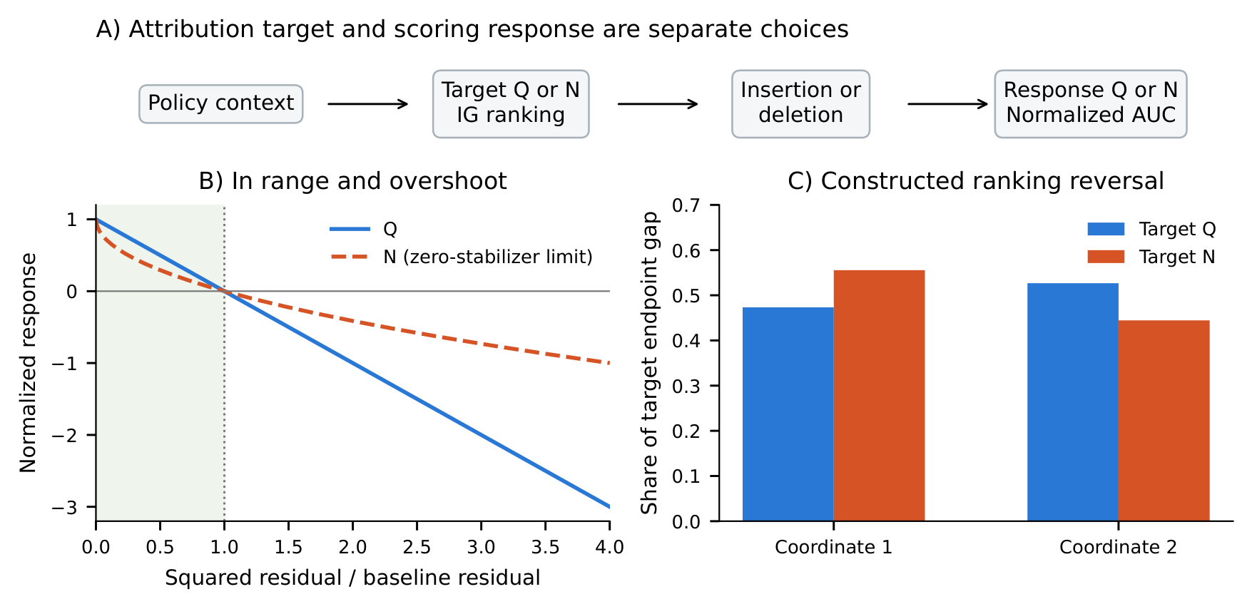
Figure 1 | Attribution target and evaluation response are separate choices. A) A fixed context produces rankings and intervention actions; Q or N can score the same actions. B) Responses in the zero-stabilizer limit: Q minus N is nonnegative in range and negative beyond the all-baseline residual. C) Exact-IG shares, divided by each target’s endpoint gap, reverse order in a constructed two-feature action map. This is not an observed PickCube ranking reversal.
Vision groups are 729 adapted patch tokens from one external image; five other camera slots remain fixed backgrounds. Replacement uses matching adapted tokens from a gray image. SigLIP ((X. Zhai, B. Mustafa, A. Kolesnikov, L. Beyer. Sigmoid loss for language image pre-training. In Proceedings of the IEEE/CVF International Conference on Computer Vision (ICCV) pg. 11941–11952, 2023. https://doi.org/10.1109/ICCV51070.2023.01100.)) and T5-XXL ((C. Raffel, N. Shazeer, A. Roberts, K. Lee, S. Narang, M. Matena, Y. Zhou, W. Li, P. J. Liu. Exploring the limits of transfer learning with a unified text-to-text transformer. Journal of Machine Learning Research. Vol. 21, pg. 1–67, 2020, https://jmlr.org/papers/v21/20-074.html.)) supply image and language representations. Language attribution operates after the adaptor over attended token positions; replacement does not rerun the encoder. Q-ranked historical runs used encoded padding/end-of-sequence tokens; N-ranked runs used the authors’ precomputed embedding with a zeroed placeholder baseline. State groups are eight active normalized coordinates, differentiated through the state adaptor against zero. Baselines are comparisons, not unique neutral inputs ((P. Sturmfels, S. Lundberg, S.-I. Lee. Visualizing the impact of feature attribution baselines. Distill. Vol. 5, pg. e22, 2020, https://doi.org/10.23915/distill.00022.)); representation-space paths need not encode valid language ((S. Sanyal, X. Ren. Discretized integrated gradients for explaining language models. In Proceedings of the 2021 Conference on Empirical Methods in Natural Language Processing (EMNLP) pg. 10285–10299, 2021. https://doi.org/10.18653/v1/2021.emnlp-main.805.)).
For target $F$, IG and the historical endpoint-inclusive estimator are
$$A_{i}^{F}=(x_{i}−x_{i}^{′})\int_{0}^{1}{f_{i}}(α) dα, E_{i,m}=\frac{x_{i}−x_{i}^{′}}{m+1}\sum_{j=0}^{m}{f_{i}}(j/m), \text{(2)}$$
where $f_{i}(α)=∂_{i}F(x^{′}+α(x−x^{′}))$. The trapezoidal estimate $T_{i,m}$ gives half weight to endpoints ((L. N. Trefethen, J. A. C. Weideman. The exponentially convergent trapezoidal rule. SIAM Review. Vol. 56, pg. 385–458, 2014, https://doi.org/10.1137/130932132.)); exactly,
$$E_{i,m}=\frac{mT_{i,m}+(x_{i}−x_{i}^{′})[f_{i}(0)+f_{i}(1)]/2}{m+1}. \text{(3)}$$
This endpoint term can cause first-order error. Historical $m=64$ bf16 runs replaced nonfinite gradients with zero without counting them. The numerical accuracy of the saved headline rankings is unverified.
R1 compares the historical kernel A0; bf16 forward/fp32 accumulation A1; fp32 forward A2; Gauss-Legendre A3 with 32, 64 and 128 nodes; and adaptive Gauss-Kronrod A4. A1/A2 share 513 nodes, yielding nested trapezoidal and endpoint-inclusive rules through 512 intervals and midpoint rules through 256. A2 covers 12 P contexts and the 21 preserved contexts. Nonfinite values are counted at every evaluated node, never replaced. A1 T512 is a finite-budget comparator. An fp32 reference is qualified only when A4 converges and A4, GL128 and A2 T512 agree pairwise within relative L1 error ${10}^{−3}$.
Interventions, calibration and statistics
Insertion restores groups from baseline; deletion replaces groups in the actual input. Group scores sum absolute attribution coordinates; mean path gradients omit the IG input-difference factor. With $B=r(x^{′})>0$, normalization and the paired response difference are
$$C_{S}(u)=\frac{S(u)−S(x^{′})}{S(x)−S(x^{′})}, Δ={AUC}_{Q}−{AUC}_{N}. \text{(4)}$$
An overshoot moves the prediction farther from the reference action than the all-baseline input, so $r>B$. Normalization is undefined for $B=0$. AUC uses trapezoidal weights over intervention fractions; larger insertion and smaller deletion areas are conventionally favored.
The saved nominal schedule is 0, 1, 5, 10, 20, 30, 50, 75 and 100%. Historical intermediate group counts use $k=max(1,round(Gp/100))$, with ties rounded to even. Pinned tokenization gives G=20, 30, 25 and 16 for PickCube, StackCube, PegInsertionSide and PickSingleYCB. Thus 1% and 5% select one group for G=16,20,25; all 3,000 headline language curves have equal saved responses there. No such equality occurs in the 800 StackCube curves. This recovers the rule, not missing historical masks. Saved analyses retain nominal weights; R1 uses preserved masks and realized fractions, with nominal-axis sensitivity results.
R1 ranks seven methods: Q/N IG and Q/N mean path gradient (PG) at A1 T512, input difference, and historical Q/N IG at A0m64. Controls are 32 random vision orders, 64 language orders and the exact random-order average for eight state groups, plus raster/reverse/centre-out vision orders, forward/reverse token orders and forward/reverse joint orders. Advantage is method-minus-random AUC for insertion and random-minus-method for deletion. Preferred means highest episode-mean advantage on common complete cases. Subtracting one common reference cannot reorder methods within a response. We therefore compare response choice, random-SD z-scaling, population and illustrative 0.4/0.5 deletion bars separately.
Episode percentile bootstrap uses 10,000 draws. Seven primary P vision-deletion contrasts use Bonferroni alpha 0.05/7; best-minus-second intervals use 0.05/4 across response/direction cells. Other intervals are descriptive. Best-method ties remain undetermined. Coverage was simulated before unblinding. The plan and amendments precede their governed results. Historical rescoring intervals use seed 0 and R1 seed 930011; neither captures training-run, checkpoint or wider task variation. We retain all finite tails and all eight dependent headline cases; emphasis on medians and positive shares was chosen retrospectively.
Diagnostic scope and ethics
Completeness measures |i​Ai−[F(x)−F(x′)]|/|F(x)−F(x′)|; coordinate change compares relative L1 maps, and ranking comparisons use Spearman, top-group overlap and intervention-mask Jaccard. We separately recompute normalized-AUC changes with one common scoring forward. Zero denominators remain undefined. The 1% completeness and 0.01 AUC-change criteria are study-specific diagnostics, not accuracy guarantees. RMS discrepancy is also retained in physical response units; its unstabilized normalized area equals N’s unstabilized area and supplies no independent normalized metric.
The earlier offline fp32 sample is separate: 12 completed RDT-170M contexts per modality and target, six episodes across four tasks, no completed RDT-1B context. Its cached function and budget comparisons demonstrate possible failures, not their prevalence in the original rankings or diffusion policies generally. Full check results remain archived. All experiments use simulation; no human or animal subjects were involved and no IRB approval was required.
Results
Response identity and saved-curve effects
Under exact self-reference, Equation 4 gives
$$C_{Q}−C_{N}=\frac{(\sqrt{r+ϵ}−\sqrt{ϵ})(\sqrt{B+ϵ}−\sqrt{r+ϵ})}{B}. \text{(5)}$$
The difference is positive for $0<r<B$, zero at endpoints and negative at overshoots. Nonnegative AUC weights therefore imply $Δ≥0$ for fully in-range curves, strictly when an interior residual receives positive weight. Lowering AUC favors deletion but disfavors insertion for the same ranking. The pointwise upper bound is 1/4; endpoint weights tighten the saved-schedule bound to 0.2175. These statements do not depend on IG accuracy.
For an additive equal-feature policy, Q introduces interactions through squaring. At 100 features, every ordering gives AUC 0.65976 on the saved schedule, versus 0.5 for unstabilized N. These are analytic reference values, not measured RDT controls. Hama’s interaction-dependent expectation explains why a universal 0.5 reference is inappropriate; 0.40 remains illustrative.
The eight positive paired medians, 0.104 to 0.159, quantify a response shift whose in-range direction was already predicted. Positive shares range from 75.6% to 94.3%, while overshoots occur in 16.0% to 74.0% of calls (Figure 2; Table 3). Six means are negative. Q-ranked vision insertion has mean $−17.10$ but median 0.104; first calls contribute $−16.92$ on the same 750-call denominator. Neither cohort establishes ranking superiority.
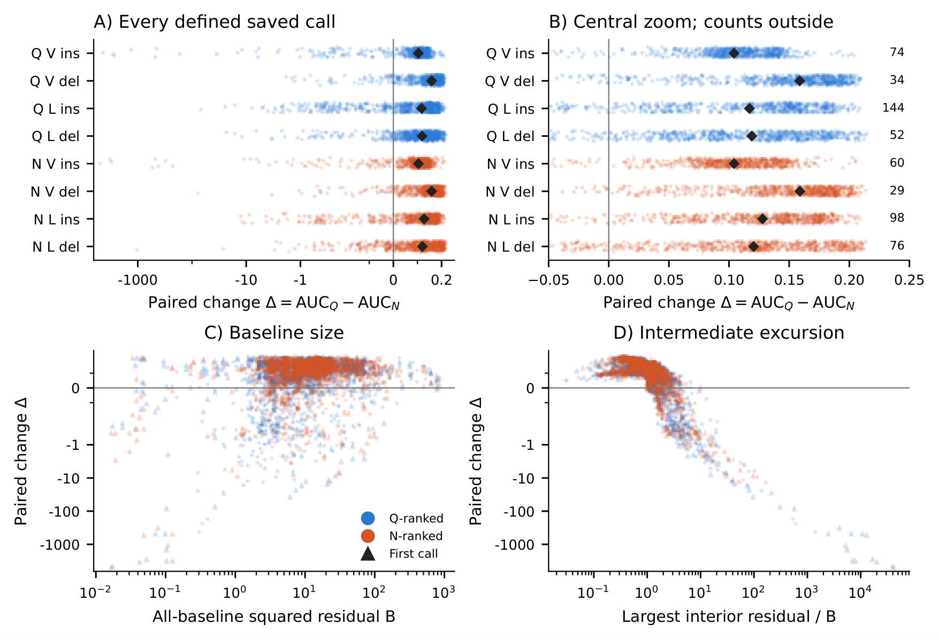
Figure 2 | Typical response shifts coexist with extreme negative tails. A) All eight headline cases on a symmetric-log scale, linear for $|Δ|≤0.25$ and logarithmic beyond it, preserving sign. B) Values in $[−0.05,0.25]$ and outside-range counts. Diamonds mark medians. C)–D) All case calls against baseline residual B and maximum interior residual/B; triangles identify first calls. Each case has 750 calls; repeated observations are dependent. No tail is removed from summaries. Geometry is descriptive.
Table 3 | Saved response-only changes retain positive medians and negative tails. Each row contains 750 calls from 30 episodes. Median and positive share weight calls equally; means weight episodes equally. Brackets are descriptive 95% whole-episode bootstrap intervals, conditional on these records, not training runs, checkpoints or tasks. V denotes vision, L language; ins insertion, del deletion. The unmatched Q- and N-ranked cohorts do not compare ranking quality.
Case | Median | Positive (%) | Overshoot (%) | Mean [interval] | Minimum
Q V ins | 0.1042 | 88.1 | 41.6 | -17.1 [-33.8, -3.97] | -4.44e+03
Q V del | 0.1588 | 92.5 | 16.9 | 0.123 [0.106, 0.138] | -1.9
Q L ins | 0.1169 | 75.6 | 74.0 | -0.182 [-0.405, -0.0277] | -71.8
Q L del | 0.1189 | 88.5 | 37.5 | -0.00947 [-0.102, 0.0631] | -23.8
N V ins | 0.1041 | 90.0 | 38.9 | -18.6 [-37.9, -3.17] | -5.24e+03
N V del | 0.1590 | 94.3 | 16.0 | 0.0184 [-0.204, 0.138] | -80.5
N L ins | 0.1279 | 84.1 | 65.5 | -0.0329 [-0.0963, 0.0266] | -13.3
N L del | 0.1205 | 83.2 | 41.6 | -1.37 [-4.21, 0.078] | -1.06e+03
The intervals in Table 3 describe variation among recorded episodes only. Outside-range counts in Figure 2 prevent the central panel from hiding tails. Vision B’s N-ranked 5th–95th percentile range is 2.914–80.798, correcting the previous rounded upper endpoint. Across 6,000 headline and 4,796 RDT-1B case calls, no $Δ<−1$ call has maximum interior residual below 2B; every $Δ<−100$ call has ratio above 100 and B below 1. Among overshooting calls, rank correlations between Delta and this ratio range from $−0.56$ to $−0.98$. Small denominators and large intervention residuals are consistent with the tail mechanism; out-of-distribution mixing remains an untested explanation.
Successful episodes and additional tasks
Historical RDT-1B PickCube supplies 60 episodes and 1,199 calls: 15 successful episodes contribute 74 calls, and 45 failed episodes contribute 1,125. Vision insertion medians are 0.0653 and 0.0868, respectively; deletion medians are 0.0747 and 0.1035. Both groups remain positive, but the successful-call sample is small (Figure 3). Insertion overshoot shares are 24.3% for successes and 29.0% for failures; deletion shares are 41.9% and 31.6%. Minimum insertion differences are $−2.35$ and $−57.72$, and deletion minima $−0.347$ and $−74.46$. Success therefore does not remove overshoots, although these saved failure groups contain more extreme negative calls. Language stays separated by seed because baselines differ. The two extra saved tasks each contain 16 unsuccessful episodes and 400 calls. PegInsertionSide vision insertion/deletion medians are 0.0990/0.1152; PickSingleYCB values are 0.0954/0.1405. PegInsertionSide’s insertion mean is $−3.54$, retaining the overshoot tail.
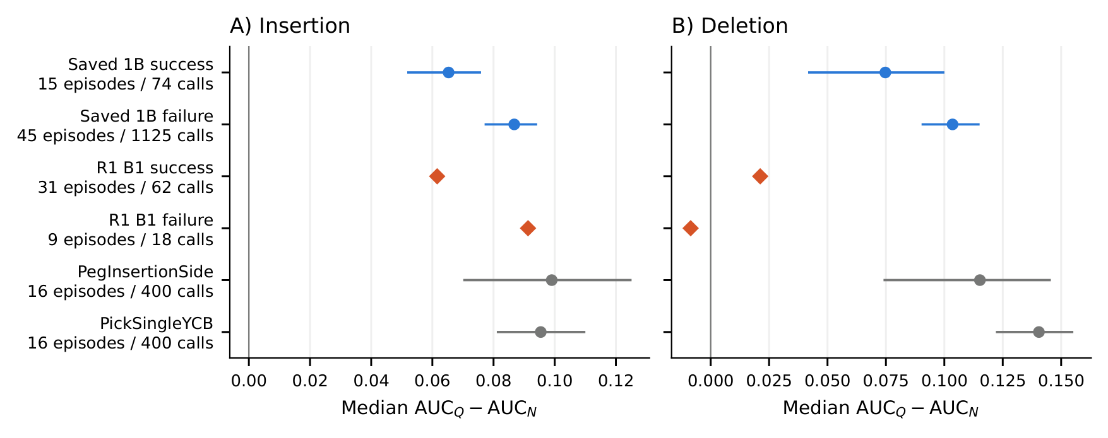
Figure 3 | Response shifts in successful episodes and additional tasks. A) Vision insertion. B) Vision deletion. Circles show historical RDT-1B and extra-task paired medians with descriptive 95% episode-bootstrap intervals. Diamonds show new B1 Q-target T512 IG medians without intervals. Displayed episode and call counts define each population. Historical and new groups remain separate; the new failed-episode deletion median is negative. These comparisons do not establish an effect on robot success.
New B1 succeeds in 31 of 40 episodes; P succeeds in none of 60 and S in none of 30. Thus the substantial R1 success comparison rests on B1’s 31 successes and nine failures. For Q-target A1 T512 IG, B1 insertion medians are 0.0616 (success) and 0.0913 (failure); deletion medians are 0.0212 and $−0.00858$. Unlike the historical split, the new failed-episode deletion median is negative. These new inputs extend the empirical scope without retrospectively validating the original unsuccessful cohorts.
Matched attribution methods and calibration
Preferred vision-deletion methods change between Q and N in P, B1 and S, while vision-insertion preferences do not (Figure 4; Table 4). Only P/Q/deletion has an adjusted best-minus-second interval excluding zero, favoring the N mean path gradient. Table 4 reports every new-bank vision cell, including whether its preferred method’s mean exceeds all fixed-order means; that flag is not a significance claim.
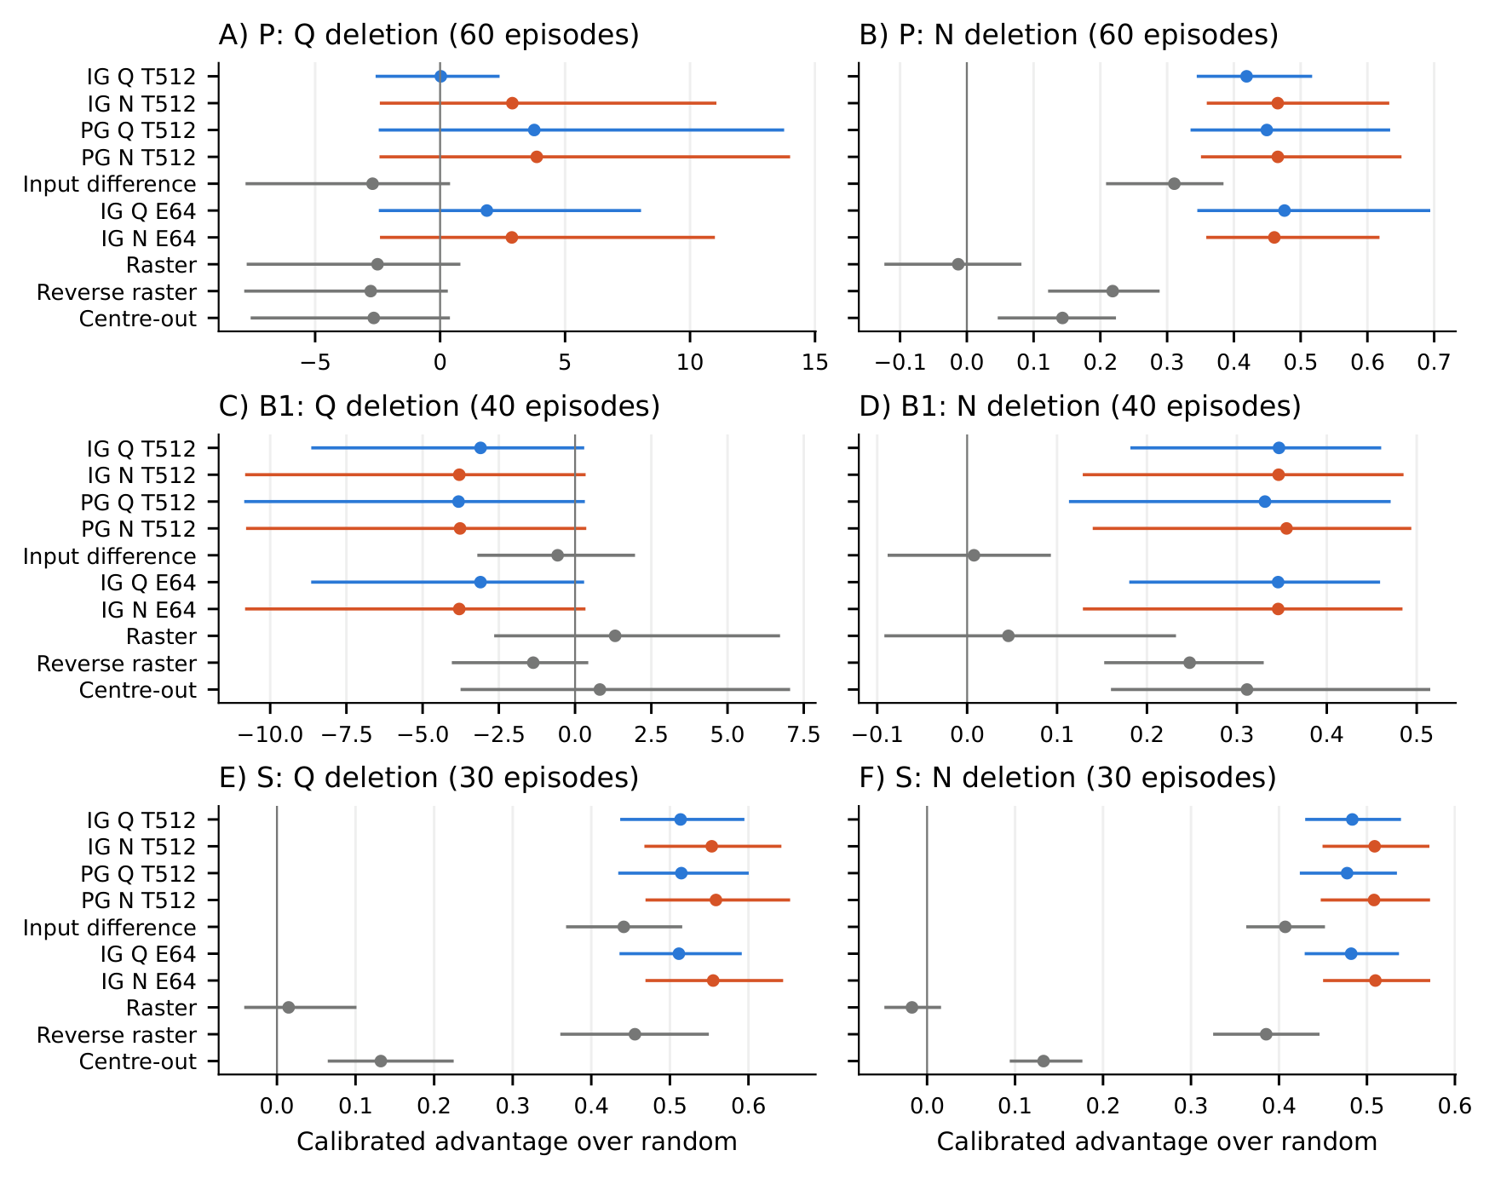
Figure 4 | Response choice changes calibrated vision-deletion comparisons. Panels show P, B1 and S under Q and N. Positive episode-mean advantage favors the ranking over the response-matched random mean. Plotted intervals are descriptive 95% episode-bootstrap intervals on common complete cases: P 60, B1 40 and S 30 episodes. Table 4 separately reports the seven corrected primary P contrasts, insertion preferences and fixed-order comparisons.
Table 4 | Preferred methods and primary contrasts. Preference maximizes calibrated advantage on complete-case episodes (P: 60; B1: 40; S: 30). Clear means the adjusted best-minus-second interval excludes zero. Above fixed orders compares point means, not significance. E64 denotes the historical A0 estimator. The following primary contrasts use P vision deletion and Bonferroni-adjusted percentile intervals (seven comparisons).
Bank | Response / direction | Preferred | Clear | Above fixed means
P | Q deletion | PG N T512 | Yes | Yes
P | Q insertion | PG N T512 | No | No
P | N deletion | IG Q E64 | No | Yes
P | N insertion | PG N T512 | No | No
B1 | Q deletion | Input difference | No | No
B1 | Q insertion | IG Q T512 | No | Yes
B1 | N deletion | PG N T512 | No | Yes
B1 | N insertion | IG Q T512 | No | Yes
S | Q deletion | PG N T512 | No | Yes
S | Q insertion | PG N T512 | No | Yes
S | N deletion | IG N E64 | No | Yes
S | N insertion | PG N T512 | No | Yes

Contrast | Response | Estimate | Adjusted interval
IG Q T512 minus random | Q | 0.028 | [-3.54, 3.12]
IG Q T512 minus random | N | 0.419 | [0.327, 0.556]
IG N T512 minus random | Q | 2.89 | [-3.41, 14.6]
IG N T512 minus random | N | 0.466 | [0.341, 0.704]
IG Q T512 minus IG N T512 | Q | -2.86 | [-11.4, -0.0115]
IG Q T512 minus IG N T512 | N | -0.0467 | [-0.146, -0.00846]
IG Q at Q minus IG N at N | matched | -0.438 | [-3.91, 2.44]
In the primary family, both T512 IG methods exceed random under N but neither separates from random under Q. IG-N exceeds IG-Q under both responses; the Q interval for IG-Q minus IG-N ends at $−0.0115$. Comparing response-matched IG-Q-at-Q against IG-N-at-N gives $−0.438$ with interval $[−3.91,2.44]$. Z-scaling changes P deletion preferences under both responses, B1 deletion under Q and B1 insertion under both. Fixed-bar decisions also differ from calibrated preferences; subtracting a common reference alone never causes a within-response reorder. Complete-case population choice does not change these preferences. Month 8 strata have at most two complete-case episodes, with simulated percentile coverage of 9%–50%; their intervals and mechanical winner flags support no inferential conclusion.
Numerical accuracy and separate diagnostic outcomes
For the reviewer’s linear example $g(u)=u$, baseline 0 and input 1, exact N attribution is approximately 0.999999. At $m=64$, endpoint-inclusive averaging gives 0.984615 (1.54% shortfall), trapezoidal integration 0.992187, midpoint 0.99999999984 and Gauss-Legendre 0.9999999958. The narrow endpoint transition explains why treating endpoints equally matters even with exact gradients.
Historical saved vision completeness residual medians are 1.96% for Q-ranked and 4.76% for N-ranked calls; 77.2% and 99.6% exceed 1%. Sums fall short of endpoint gaps in 87.5% and 99.1%. Every stored sum is bf16-valued, but storage rounding alone cannot explain the one-sided deficit.
In P vision, increasing trapezoidal intervals from 64 to 512 changes A1 bf16-forward median residuals only from 0.0403 to 0.0351 for N and 0.00865 to 0.00834 for Q. A2 fp32 values fall from 0.0154 to 0.00192 and $2.61×{10}^{−4}$ to $3.21×{10}^{−6}$ (Figure 5). The same floor-versus-decrease pattern holds on the matched 12 contexts. Historical maps differ from the bf16 T512 comparator by median relative L1 0.0207 (N) and 0.0182 (Q); against fp32 T512 the corresponding 12-context medians are 0.0603 and 0.0321. Forward precision, not simply adding nodes, therefore limits these bf16 comparisons.
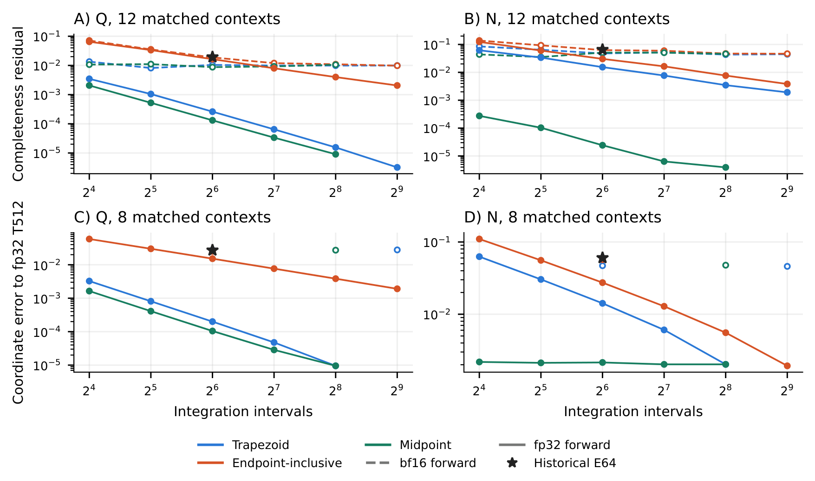
Figure 5 | Completeness and coordinate differences depend on precision and budget. A)–B) Median Q/N completeness residuals on 12 matched P vision contexts. C)–D) Median relative L1 differences from fp32 T512 on eight matched contexts with stored rule comparisons. E, T and M denote endpoint-inclusive, trapezoidal and midpoint rules; stars mark A0. Dashed curves use bf16 forward, solid curves fp32. The comparator’s zero difference is omitted on the log axis. Neither finite-budget comparison nor completeness certifies exact IG.
Ranking stability does not remove score sensitivity. For A0 versus A1 T512 on 120 P vision contexts, median group Spearman is about 0.999975 under both targets and median top-5% overlap is 1. Nevertheless, N-target deletion AUC changes exceed 0.01 in seven contexts scored with N and 12 scored with Q; Q-target counts are four and 12. Maximum Q-scored deletion change for the Q-target comparison is 221.03. All four diagnostics therefore require separate reporting.
No NaN or infinity occurs at 815,210 evaluated nodes. A4 converges in all 48 reference comparisons, but strict three-way qualification holds for only 5 of 24 N comparisons; convergence alone does not establish the reference. A0 residuals depend on GPU summation order, so the per-context fp32-sum alternative is retained. No fp64 model run was performed. The earlier separate offline fp32 sample likewise shows that repeated equality checks can pass while budget comparisons fail; its limited sample is not a failure-rate estimate. The short appendix gives constructed exact-ranking reversal and aliasing examples, not observed robot-policy reversals.
Discussion
Our analytic result isolates a scoring effect that persists with unchanged actions and arbitrary rankings. The saved unsuccessful runs quantify its size and tails; successful 1B episodes and extra tasks broaden the observed scope without implying universal effect sizes. The matched R1 study answers a different practical question: changing the response can change the preferred method after response-matched calibration. Most best-versus-second intervals still include zero, so selecting the highest mean is weaker evidence than establishing a clear winner.
Hama’s random-order result concerns feature interactions and unnormalized full-prefix areas. Their sufficient condition uses a strictly increasing differentiable transform of an additive inner model on binary features. Its IG argument extends the inner model affinely along the path, so gradients have a common coordinate order when $h^{′}>0$. Our construction has a varying path-gradient direction and does not satisfy that condition. Our additional findings concern separate targets and responses, endpoint normalization, overshoots and numerical recovery in a vector-output policy. They do not replace general interaction results. Compared with intervention and metric studies, we hold interventions fixed to isolate the response. Compared with exact-integration work, our finite diagnostics expose limitations without certifying coordinates. No model-weight randomization study was performed ((J. Adebayo, J. Gilmer, M. Muelly, I. J. Goodfellow, M. Hardt, B. Kim. Sanity checks for saliency maps. In Advances in Neural Information Processing Systems (NeurIPS) Vol. 31 pg. 9525–9536, 2018. https://proceedings.neurips.cc/paper_files/paper/2018/hash/294a8ed24b1ad22ec2e7efea049b8737-Abstract.html.)).
A practical evaluation should specify target, response, reference, noise, groups, baselines and masks; compare rankings in identical contexts with response-matched random and fixed controls; and report undefined gaps, unnormalized residuals, medians and full tails alongside means. Episode-level resampling respects repeated calls. Completeness, coordinate convergence, rank stability and perturbation-score stability should be reported separately across budgets and precisions. Passing a finite set of checks does not guarantee a correct integral or improved robot behavior.
Limitations and conclusion
The numerical accuracy of the saved headline rankings is unverified. Their missing original inputs cannot be restored by R1’s regeneration success. Historical cohorts are not matched ranking comparisons; all original headline episodes, P and S fail. Successful evidence rests mainly on historical 1B and B1, with differing seeds, language inputs and runtimes. Month 8 samples are too small for population inference, and partially replaced inputs have no demonstrated causal explanation here. The separate offline fp32 sample and R1 subsets show what can occur, not general numerical failure frequencies.
The mathematical identity establishes the direction of fully in-range response changes. Saved and new experiments establish conditional effects in their recorded contexts, including successful 1B episodes and response-dependent preferred methods. Numerical comparisons and counterexamples establish limits on particular estimators and checks. These conclusions justify explicit response calibration and qualified numerical reporting, not general ranking superiority or improved task success.
Data and code availability
The research supplement contains code, the 99 saved JSONL files, analyses, results and extended derivations. The reviewer archive adds R1 protocols, collections, identity inventories, the preserved Month 8 bundle and a regeneration kit; the complete tensor bundle supports registered-analysis replay. Saved curves reproduce on CPU, but missing inputs prevent regeneration of original headline policy evaluations. The kit regenerated a new result from preserved observations and noise on a fresh machine. Anonymous downloads and SHA-256 manifests are in the review archive. This unlisted link requires no account; anyone holding it can download. Code and saved analysis are at https://github.com/itscool2b/ig-response-geometry. The submitted snapshot remains tagged manuscript-2026-10-04-polish; this revision is a distinct version.
AI-use disclosure
OpenAI Codex, Claude Code, pi.dev, and Cursor were used to assist with writing and debugging code, running and interpreting analyses, and searching the literature.
Acknowledgments
I thank Professor Sumit K. Jha and Brian Rodriguez at the University of Florida for mentoring me and providing technical advice throughout this project.
Funding: This research received no external funding.
Author contributions: A.B. conceived and directed the study, evaluated the analyses, and takes responsibility for the manuscript and its conclusions.
Competing interests: The author declares no competing interests.
References
1. C. Chi, S. Feng, Y. Du, Z. Xu, E. Cousineau, B. C. M. Burchfiel, S. Song. Diffusion policy: Visuomotor policy learning via action diffusion. In Proceedings of Robotics: Science and Systems (RSS) 2023. https://doi.org/10.15607/RSS.2023.XIX.026.
2. H. Zhang, M. Xu, A. Dhafer, S. Yue, H. Dong, Z. D. Hao. Embodied interpretability: Linking causal understanding to generalization in vision-language-action models. In Proceedings of the 43rd International Conference on Machine Learning (ICML) Vol. 306 pg. 159526–159549, 2026. https://proceedings.mlr.press/v306/zhang26gz.html.
3. M. Sundararajan, A. Taly, Q. Yan. Axiomatic attribution for deep networks. In Proceedings of the 34th International Conference on Machine Learning (ICML) Vol. 70 pg. 3319–3328, 2017. https://proceedings.mlr.press/v70/sundararajan17a.html.
4. S. Liu, L. Wu, B. Li, H. Tan, H. Chen, Z. Wang, K. Xu, H. Su, J. Zhu. RDT-1B: A diffusion foundation model for bimanual manipulation. In Proceedings of the International Conference on Learning Representations (ICLR) pg. 29982–30009, 2025. https://proceedings.iclr.cc/paper_files/paper/2025/hash/49f80e4d2471ad4f2edf4f5f1ab62339-Abstract-Conference.html.
5. V. Petsiuk, A. Das, K. Saenko. RISE: Randomized input sampling for explanation of black-box models. In Proceedings of the British Machine Vision Conference (BMVC) 2018. https://bmva-archive.org.uk/bmvc/2018/contents/papers/1064.pdf.
6. S. Hooker, D. Erhan, P.-J. Kindermans, B. Kim. A benchmark for interpretability methods in deep neural networks. In Advances in Neural Information Processing Systems (NeurIPS) Vol. 32 pg. 9734–9745, 2019. https://proceedings.neurips.cc/paper_files/paper/2019/hash/fe4b8556000d0f0cae99daa5c5c5a410-Abstract.html.
7. Y. Rong, T. Leemann, V. Borisov, G. Kasneci, E. Kasneci. A consistent and efficient evaluation strategy for attribution methods. In Proceedings of the 39th International Conference on Machine Learning (ICML) Vol. 162 pg. 18770–18795, 2022. https://proceedings.mlr.press/v162/rong22a.html.
8. R. Tomsett, D. Harborne, S. Chakraborty, P. Gurram, A. Preece. Sanity checks for saliency metrics. In Proceedings of the AAAI Conference on Artificial Intelligence Vol. 34 pg. 6021–6029, 2020. https://doi.org/10.1609/aaai.v34i04.6064.
9. I. Covert, S. Lundberg, S.-I. Lee. Explaining by removing: A unified framework for model explanation. Journal of Machine Learning Research. Vol. 22, pg. 1–90, 2021, https://jmlr.org/papers/v22/20-1316.html.
10. P. Hase, H. Xie, M. Bansal. The out-of-distribution problem in explainability and search methods for feature importance explanations. In Advances in Neural Information Processing Systems (NeurIPS) Vol. 34 pg. 3650–3666, 2021. https://proceedings.neurips.cc/paper_files/paper/2021/hash/1def1713ebf17722cbe300cfc1c88558-Abstract.html.
11. T. Gomez, T. Fréour, H. Mouchère. Metrics for saliency map evaluation of deep learning explanation methods. In Pattern Recognition and Artificial Intelligence. ICPRAI 2022. Lecture Notes in Computer Science Vol. 13363 pg. 84–95, 2022. https://doi.org/10.1007/978-3-031-09037-0_8.
12. A. Hedström, P. L. Bommer, K. K. Wickstrøm, W. Samek, S. Lapuschkin, M. M.-C. Höhne. The meta-evaluation problem in explainable AI: Identifying reliable estimators with MetaQuantus. Transactions on Machine Learning Research. 2023, https://openreview.net/forum?id=j3FK00HyfU.
13. S. Blücher, J. Vielhaben, N. Strodthoff. Decoupling pixel flipping and occlusion strategy for consistent XAI benchmarks. Transactions on Machine Learning Research. 2024, https://openreview.net/forum?id=bIiLXdtUVM.
14. A. Mamalakis, E. A. Barnes, I. Ebert-Uphoff. Carefully choose the baseline: Lessons learned from applying XAI attribution methods for regression tasks in geoscience. Artificial Intelligence for the Earth Systems. Vol. 2, 2023, https://doi.org/10.1175/AIES-D-22-0058.1.
15. A. Atrey, K. Clary, D. Jensen. Exploratory not explanatory: Counterfactual analysis of saliency maps for deep reinforcement learning. In Proceedings of the International Conference on Learning Representations (ICLR) 2020. https://openreview.net/forum?id=rkl3m1BFDB.
16. T. Huber, B. Limmer, E. André. Benchmarking perturbation-based saliency maps for explaining Atari agents. Frontiers in Artificial Intelligence. Vol. 5, pg. 903875, 2022, https://doi.org/10.3389/frai.2022.903875.
17. S. Kim, J. Choi. Explaining the decisions of deep policy networks for robotic manipulations. In Proceedings of the IEEE/RSJ International Conference on Intelligent Robots and Systems (IROS) pg. 2663–2669, 2021. https://doi.org/10.1109/IROS51168.2021.9636594.
18. B. Häon, K. C. Stocking, I. Chuang, C. Tomlin. Mechanistic interpretability for steering vision-language-action models. In Proceedings of the 9th Conference on Robot Learning (CoRL) Vol. 305 pg. 2743–2762, 2025. https://proceedings.mlr.press/v305/haon25a.html.
19. N. Hama, M. Mase, A. B. Owen. Deletion and insertion tests in regression models. Journal of Machine Learning Research. Vol. 24, pg. 1–38, 2023, https://jmlr.org/papers/v24/22-0560.html.
20. D. D. Lundstrom, T. Huang, M. Razaviyayn. A rigorous study of integrated gradients method and extensions to internal neuron attributions. In Proceedings of the 39th International Conference on Machine Learning (ICML) Vol. 162 pg. 14485–14508, 2022. https://proceedings.mlr.press/v162/lundstrom22a.html.
21. B. Bilodeau, N. Jaques, P. W. Koh, B. Kim. Impossibility theorems for feature attribution. Proceedings of the National Academy of Sciences. Vol. 121, pg. e2304406120, 2024, https://doi.org/10.1073/pnas.2304406120.
22. M. Sotoudeh, A. V. Thakur. Computing linear restrictions of neural networks. In Advances in Neural Information Processing Systems (NeurIPS) Vol. 32 pg. 14132–14143, 2019. https://proceedings.neurips.cc/paper_files/paper/2019/hash/908075ea2c025c335f4865f7db427062-Abstract.html.
23. L. Arras, A. Osman, W. Samek. CLEVR-XAI: A benchmark dataset for the ground truth evaluation of neural network explanations. Information Fusion. Vol. 81, pg. 14–40, 2022, https://doi.org/10.1016/j.inffus.2021.11.008.
24. M. Makino, Y. Asazuma, S. Sasaki, J. Suzuki. The impact of integration step on integrated gradients. In Proceedings of the 18th Conference of the European Chapter of the Association for Computational Linguistics: Student Research Workshop (EACL) pg. 279–289, 2024. https://doi.org/10.18653/v1/2024.eacl-srw.22.
25. R. Yang, B. Wang, M. Bilgic. IDGI: A framework to eliminate explanation noise from integrated gradients. In Proceedings of the IEEE/CVF Conference on Computer Vision and Pattern Recognition (CVPR) pg. 23725–23734, 2023. https://doi.org/10.1109/CVPR52729.2023.02272.
26. Robotics Diffusion Transformer team. RDT-170M model card. https://huggingface.co/robotics-diffusion-transformer/rdt-170m 2024.
27. C. Lu, Y. Zhou, F. Bao, J. Chen, C. Li, J. Zhu. DPM-Solver++: Fast solver for guided sampling of diffusion probabilistic models. Machine Intelligence Research. Vol. 22, pg. 730–751, 2025, https://doi.org/10.1007/s11633-025-1562-4.
28. S. Tao, F. Xiang, A. Shukla, Y. Qin, X. Hinrichsen, X. Yuan, C. Bao, X. Lin, Y. Liu, T.-K. Chan, Y. Gao, X. Li, T. Mu, N. Xiao, A. Gurha, V. N. Rajesh, Y. W. Choi, Y.-R. Chen, Z. Huang, R. Calandra, R. Chen, S. Luo, H. Su. Demonstrating GPU parallelized robot simulation and rendering for generalizable embodied AI with ManiSkill3. In Proceedings of Robotics: Science and Systems (RSS) 2025. https://doi.org/10.15607/RSS.2025.XXI.021.
29. X. Zhai, B. Mustafa, A. Kolesnikov, L. Beyer. Sigmoid loss for language image pre-training. In Proceedings of the IEEE/CVF International Conference on Computer Vision (ICCV) pg. 11941–11952, 2023. https://doi.org/10.1109/ICCV51070.2023.01100.
30. C. Raffel, N. Shazeer, A. Roberts, K. Lee, S. Narang, M. Matena, Y. Zhou, W. Li, P. J. Liu. Exploring the limits of transfer learning with a unified text-to-text transformer. Journal of Machine Learning Research. Vol. 21, pg. 1–67, 2020, https://jmlr.org/papers/v21/20-074.html.
31. P. Sturmfels, S. Lundberg, S.-I. Lee. Visualizing the impact of feature attribution baselines. Distill. Vol. 5, pg. e22, 2020, https://doi.org/10.23915/distill.00022.
32. S. Sanyal, X. Ren. Discretized integrated gradients for explaining language models. In Proceedings of the 2021 Conference on Empirical Methods in Natural Language Processing (EMNLP) pg. 10285–10299, 2021. https://doi.org/10.18653/v1/2021.emnlp-main.805.
33. L. N. Trefethen, J. A. C. Weideman. The exponentially convergent trapezoidal rule. SIAM Review. Vol. 56, pg. 385–458, 2014, https://doi.org/10.1137/130932132.
34. J. Adebayo, J. Gilmer, M. Muelly, I. J. Goodfellow, M. Hardt, B. Kim. Sanity checks for saliency maps. In Advances in Neural Information Processing Systems (NeurIPS) Vol. 31 pg. 9525–9536, 2018. https://proceedings.neurips.cc/paper_files/paper/2018/hash/294a8ed24b1ad22ec2e7efea049b8737-Abstract.html.
Short analytic proofs
Set $η=\sqrt{ϵ}$, $b=\sqrt{B+ϵ}$ and $z=\sqrt{r+ϵ}$. Because $B=(b−η)(b+η)$, subtracting the normalized responses gives $(z−η)(b−z)/B$, proving Equation 5. In range its maximum is $(b−η)/[4(b+η)]≤1/4$. Beyond range it is negative. The saved schedule gives zero endpoint differences total weight 0.13, hence $Δ≤0.87/4=0.2175$. If B=0 normalization is undefined. Equal saved 1%/5% values make deletion of the 1% node change their combined weight by 0.02, bounding its in-range paired effect by 0.005.
For scalar action examples set $d_{a}=1$. With $g(x_{1},x_{2})=x_{1}^{2}+(4/5)x_{2}$, baseline (0,0), input (1,1) and reference 9/5, polynomial integration gives $A^{Q}=(23/30,64/75)$. Writing $ρ(α)=(1−α)(1+α+4/5)$, N’s gradient is $ρ(α)(2α,4/5)/\sqrt{ρ(α)^{2}+ϵ}$. The inequality $ρ≥(4/5)(1−α)$ bounds the coordinate deficits from (1,4/5) by $2.5×{10}^{−6}$ and ${10}^{−6}$ at the chosen epsilon. Thus N ranks feature 1 first while Q ranks feature 2 first. This is a constructed possibility, not an observed PickCube reversal.
Aliasing and diagnostic limits
For positive integer K, let $h(α)=(2/5)\sin^{2}(πKα)$ and
$$g(x_{1},x_{2})=\frac{2}{5}x_{1}+\frac{3}{5}x_{2}+(x_{1}−x_{2})h((x_{1}+x_{2})/2). \text{(6)}$$
With baseline (0,0), input (1,1) and reference 1, Q’s path gradient is $(1−α)(2/5+h,3/5−h)$. Every uniform budget m dividing K samples h=0. Trapezoidal and endpoint-inclusive estimates then give (1/5,3/10), with exact completeness and identical rankings. Symmetry gives $\int_{0}^{1}{(}1−α)h(α) dα=1/10$, so exact IG is (3/10,1/5), reversing the order. Any finite set of uniform budgets can be hidden by a common multiple K. Completeness cancellation and grid agreement therefore cannot certify coordinates without additional regularity information. At K=128 the inaccurate order even has better insertion and deletion scores on the three-point intervention grid. Exact integration and perturbation-score optimization remain distinct. Full constructions, finite-stabilizer bounds and calibration derivations are in the supplementary derivations.

